

**Mawlana Bhashani Science & Technology University**

**Lab Report No : 03**

**Course Code : ICT-3106**

**Course Title : Microprocessor and Assembly Language Lab**

**Submitted by Submitted to**

**Name : Maskur Al Shal Sabil S.M. Shamim**

**Id: IT18021 Lecturer**

**3rd year 1st semester Dept of ICT,**

**Session : 2017-2018 MBSTU**

**Dept of ICT**

**MBSTU**

1. Write an assembly program to display different triangle using asterisk and digit.

|  |  |  |  |  |  |  |  |  |  |
| --- | --- | --- | --- | --- | --- | --- | --- | --- | --- |
|  |  |  |  |  |  | 1 |  |  |  |
|  |  |  |  |  | 1 | 1 |  |  |  |
|  |  |  |  | 1 |  | 1 |  |  |  |
|  |  |  | 1 |  |  | 1 |  |  |  |
|  |  | 1 | 1 | 1 | 1 | 1 |  |  |  |

|  |  |  |  |  |  |  |  |  |  |  |  |  |  |  |  |  |  |  |  |
| --- | --- | --- | --- | --- | --- | --- | --- | --- | --- | --- | --- | --- | --- | --- | --- | --- | --- | --- | --- |
|  |  |  |  |  |  |  |  |  |  |  |  |  |  |  |  |  |  |  |  |
|  |  |  |  |  |  |  |  |  | * | * |  |  |  |  |  |  |  |  |  |
|  |  |  |  |  |  |  |  | * |  |  | * |  |  |  |  |  |  |  |  |
|  |  |  |  |  |  |  | * |  |  |  |  | * |  |  |  |  |  |  |  |
|  |  |  |  |  |  | * |  |  |  |  |  |  | * |  |  |  |  |  |  |
|  |  |  |  |  | * |  |  |  |  |  |  |  |  | * |  |  |  |  |  |
|  |  |  |  | * |  |  |  |  |  |  |  |  |  |  | * |  |  |  |  |
|  |  |  | * |  |  |  |  |  |  |  |  |  |  |  |  | * |  |  |  |
|  |  | * |  |  |  |  |  |  |  |  |  |  |  |  |  |  | * |  |  |
|  | * |  |  |  |  |  |  |  |  |  |  |  |  |  |  |  |  | * |  |
| * | * | * | * | * | * | * | * | * | * | * | * | * | * | * | * | * | * | * | * |
|  |  |  |  |  |  |  |  |  |  |  |  |  |  |  |  |  |  |  |  |

Code:

.model small

.stack 100h

.data

triangle_num db 'triangle using digit:',0dh,0ah,'$'

triangle_star db 0ah,'triangle using star: ',0dh,0ah,'$'

row1 db ' 1',0dh,0ah,'$'

row2 db ' 11',0dh,0ah,'$'

row3 db ' 1 1', 0dh,0ah ,'$'

row4 db ' 1 1',0dh,0ah, '$'

row5 db '11111',0dh,0ah, '$'

r1 db ' ** ',0dh,0ah,'$'

r2 db ' * * ',0dh,0ah,'$'

r3 db ' * * ',0dh,0ah,'$'

r4 db ' * * ',0dh,0ah,'$'

r5 db ' * * ',0dh,0ah,'$'

r6 db ' * * ',0dh,0ah,'$'

r7 db ' * * ',0dh,0ah,'$'

r8 db ' * * ',0dh,0ah, '$'

r9 db ' * * ',0dh,0ah,'$'

r10 db '********************',0dh,0ah, '$'

.code

main proc

mov ax,@data

mov ds,ax

lea dx,triangle_num

mov ah,9

int 21h

lea dx,row1

mov ah,9

int 21h

lea dx,row2

mov ah,9

int 21h

lea dx,row3

mov ah,9

int 21h

lea dx,row4

mov ah,9

int 21h

lea dx,row5

mov ah,9

int 21h

;print star triangle

lea dx,triangle_star

mov ah,9

int 21h

lea dx,r1

mov ah,9

int 21h

lea dx,r2

mov ah,9

int 21h

lea dx,r3

mov ah,9

int 21h

lea dx,r4

mov ah,9

int 21h

lea dx,r5

mov ah,9

int 21h

lea dx,r6

mov ah,9

int 21h

lea dx,r7

mov ah,9

int 21h

lea dx,r8

mov ah,9

int 21h

lea dx,r9

mov ah,9

int 21h

lea dx,r10

mov ah,9

int 21h

main endp

end main

output :

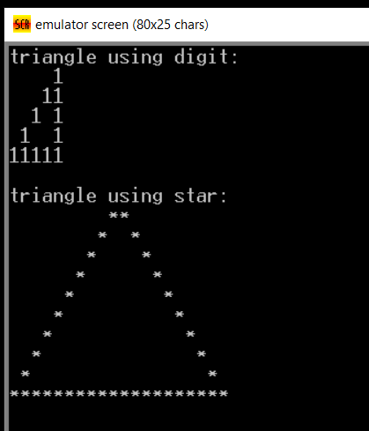

**2. Write an assembly program to enter two 8 bit numbers and print their sum which is less than 9.**

**Note : to get asscii to number we a sub 30h with the decimal char**

**Code:**

.model small

.stack 100h

.data

first db 'enter first number : $'

second db 0dh,0ah,'endter second number : $'

sum db 0dh,0ah,'sum is :$'

.code

main proc

mov ax,@data

mov ds,ax

lea dx,first

mov ah,9

int 21h

mov ah,1

int 21h ; read first number

mov bl,al

lea dx,second

mov ah,9

int 21h

mov ah,1

int 21h

mov bh,al

sub bl,30h

sub bh,30h

add bl,bh

add bl,30h

; print sum

lea dx,sum

mov ah,9

int 21h

mov ah,2

mov dl,bl

int 21h

main endp

end main

**output :** 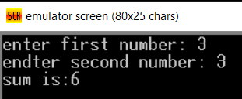

**3. Write an assembly program to enter two 8 bit numbers and print their sum which is larger than 9**.

.model small

.stack 100h

.data

a db 0

b db 0

msg db 'enter 1st number : $'

msg2 db 0dh,0ah,'enter 2nd number : $'

sum db 0dh,0ah,'sum is : $'

.code

main proc

mov ax,@data

mov ds,ax

lea dx,msg

mov ah,9

int 21h

mov ah,1

int 21h

mov a,al

lea dx,msg2

mov ah,9

int 21h

mov ah,1

int 21h

mov b,al

add al,a

mov ah,0

aaa

mov bx,ax; bx=bh,bl

add bl,30h

add bh,30h

lea dx,sum

mov ah,9

int 21h

mov ah,2

mov dl,bh

int 21h

mov ah,2

mov dl,bl

int 21h

main endp

end main

Output:

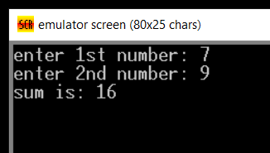

4. Write an assembly program to enter a number and perform multiplication with itself which less than 9.

Code:

.model small

.data

msg db 'enter a number : $'

result db 0dh,0ah, 'After multiplying with itself : $'

.code

main proc

mov ax,@data

mov ds,ax

lea dx,msg

mov ah,9

int 21h

mov ah,1 ; read a numebr as character

int 21h

sub ax,30h ; subtract 30h to get number

mul ax ; multiply with itself

add ax,30h ; add 30h to convert to char

mov bx,ax

lea dx,result

mov ah,9

int 21h

mov ah,2

mov dx,bx

int 21h

main endp

end main

output:

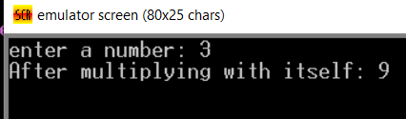

5. Write an assembly program to enter a number and perform multiplication with itself which

larger than 9.

.model small

.stack 100h

.data

num1 db 'enter 1st number : $'

num2 db 0dh,0ah,'enter 2nd numebr : $'

result db 0dh,0ah,'Multiplication : $'

.code

main proc

mov ax,@data

mov ds,ax

lea dx,num1

mov ah,9

int 21h

mov ah,1

int 21h

mov bl,al

sub bl,30h

sub al,30h

mul bl

aam

mov cx,ax

add cl,30h

add ch,30h

lea dx,result

mov ah,9

int 21h

mov ah,2

mov dl,ch

int 21h

mov dl,cl

int 21h

main endp

end main

Output:

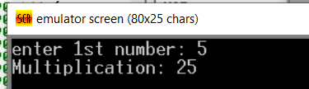

6. Write an assembly program to enter two numbers and perform division.

.model small

.stack 100h

.data

divisor db 'enter the divisor : $'

divident db 0dh,0ah,'enter the divident :$'

rem db 0dh,0ah,'reminder : $'

quotient db 0dh,0ah,'quotient : $'

.code

main proc

mov ax,@data

mov ds,ax

lea dx,divisor

mov ah,9

int 21h

mov ah,1

int 21h

sub ax,30h

mov bl,al

lea dx,divident

mov ah,9

int 21h

mov ah,1

int 21h

sub al,30h

mov ah,0

div bl

mov bx,ax

add bh,30h

add bl,30h

lea dx,quotient

mov ah,9

int 21h

mov ah,2

mov dl,bl

int 21h

lea dx,rem

mov ah,9

int 21h

mov ah,2

mov dl,bh

int 21h

main endp

end main

output:

